AEM TASK 2

**1. What is DAM and Why Do We Use It?**

* **DAM (Digital Asset Management)** is a system that allows organizations to store, organize, and manage digital assets (images, videos, documents, etc.).
* **Why we use it?**
  + Centralized storage for assets
  + Easy retrieval and management
  + Versioning and workflow integration
  + Enhanced security and access control

**2. What Are Renditions?**

* **Renditions** are automatically generated versions of an image in different sizes and formats when you upload it to **DAM**.
* To check renditions:
  + Navigate to the uploaded image in **DAM**
  + Click on the image
  + Go to the **Renditions** tab

3. **Create one folder inside our project folder and follow the path:**

**“/content/dam/myTraining/us/en-us” and upload 2 images and author those images on page**

**using image component as we see today.**

answer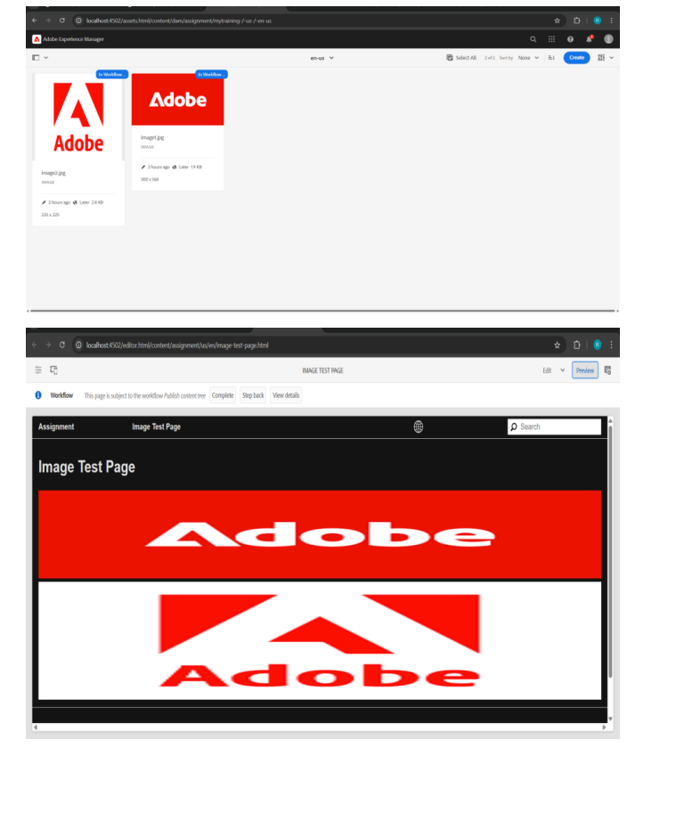

4. **3 What is renditions? Check the renditions for 2 images which we had uploaded**

Renditions are automatically generated versions of an image with different sizes and formats

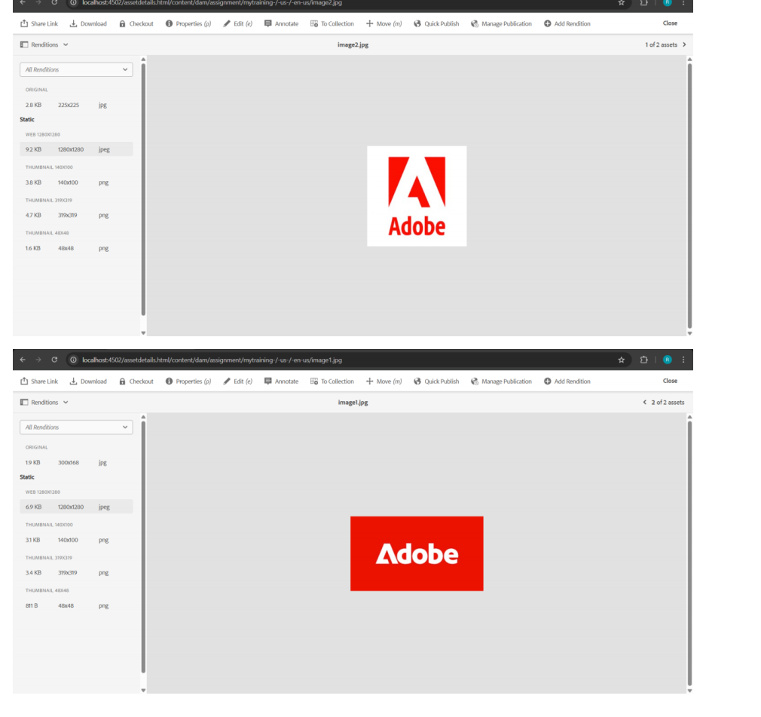

5.**.Add two fields in hello world component with name FirstName and Last Name and print the**

**values on hello world.html component using properties**

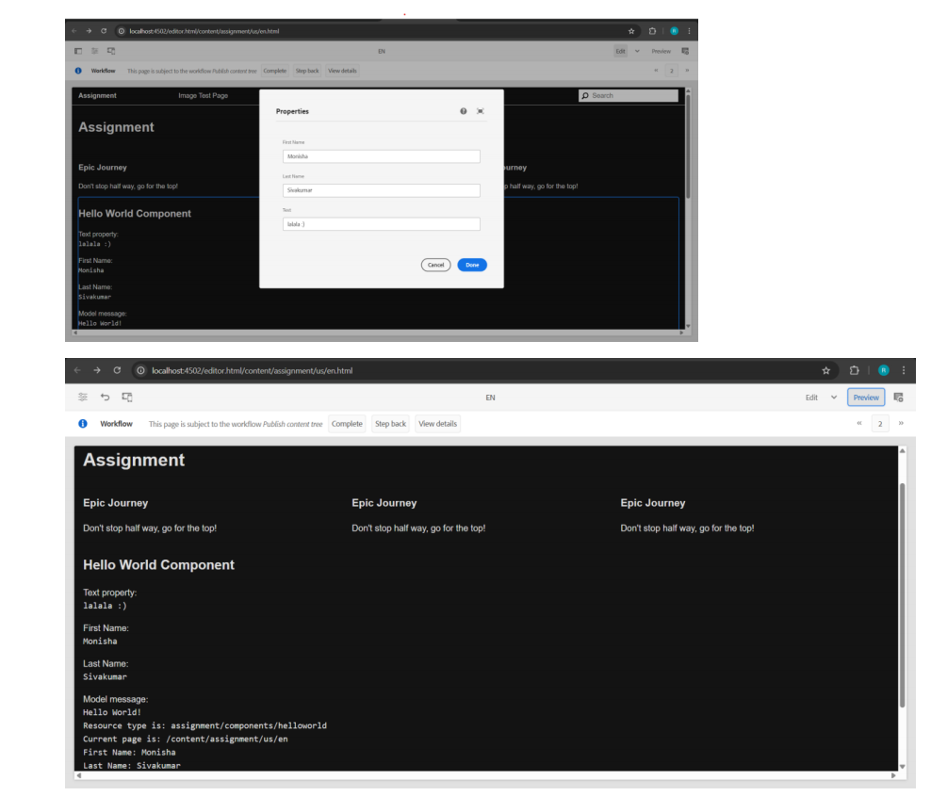

6. **Give try using @ValueMapValue annotation on HelloWorldModel sling java model**

**“com.myTraining.core.models.HelloWorldModel”**

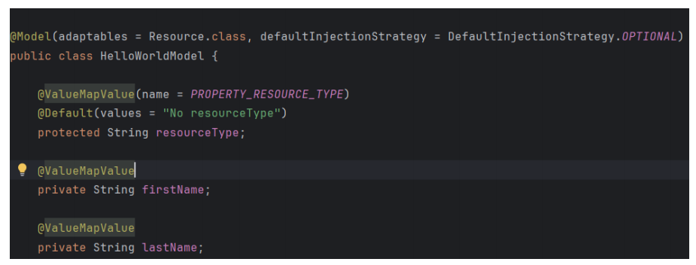

7. **Why we are using package manager and jar create package for the hello world component and 2**

**images what we have uploaded, There should be 2 packages 1 for dam which is images and 2 one**

**is for helloworld component.**

AEM’s Package Manager helps in exporting, transferring, and deploying content and code between

AEM instances.

1.Content Migration → Move assets, components, or configurations from one AEM instance to

another.

2. Backup & Restore → Store a package as a backup and reinstall if needed.

3. Deployment & Versioning → Packages help in structured and controlled deployment of code and

assets

